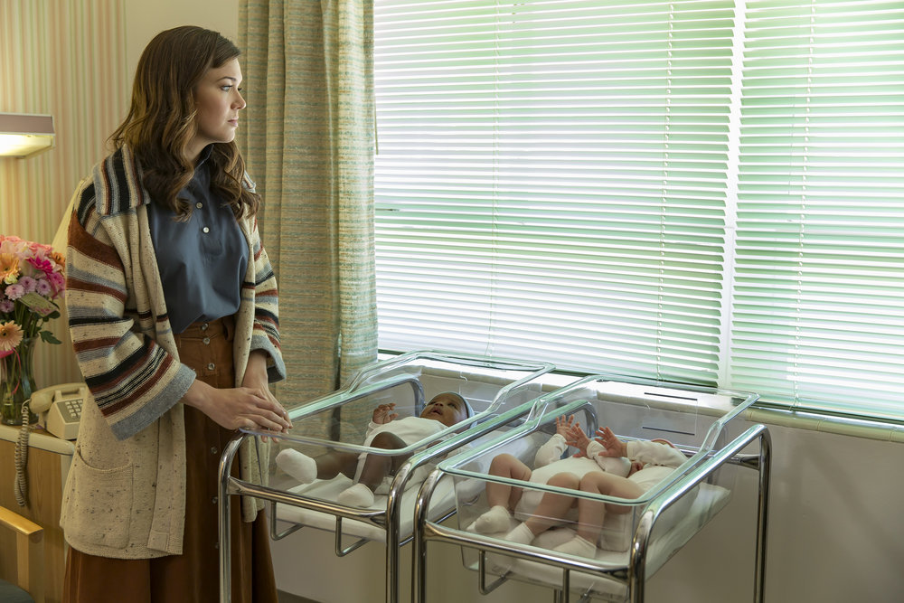

info
- THIS IS US -- Pilot -- Pictured: (l-r) Mandy Moore as Rebecca, Milo Ventimiglia as Jack -- (Photo by: Ron Batzdorff/NBC)
NUP_172430_0283.JPG
Tuesdays on NBC (9-10:00 p.m. ET)
Episodic
Posted: May 12, 2016
2016 NBCUniversal Media, LLC
image 78 of

